Question 1
Index.html

<!DOCTYPE html>
<html lang="en">
<head>
<meta charset="UTF-8">
<meta name="viewport" content="width=device-width, initial-scale=1.0">
<title>Document</title>
</head>
<body>
<p class="english">hi</p>
<p class="english">hello</p>
<p id="spanish">thing is</p>
<br />
<img src="https://i.pinimg.com/originals/6c/88/6d/6c886d3a524218c384ea11e7f5bb90f2.jpg" width="200"
id="image">
<button onclick="ButtonOne()">clickFirst</button>
<button onclick="ButtonTwo()">clickSecond</button>
<button onclick="ButtonThree()">clickThired</button>

<script src="Functions.js">

</script>
</body>
</html>

Function.js

function ButtonTwo() {
const ele=document.getElementById("image");
const newUrl="https://encrypted-tbn0.gstatic.com/images?q=tbn%3AANd9GcSo4GLY4RtxI9Uw8wATX1cWzOsWQLRvZEYVfT0SZkU1k3Ez6e3D3jTxpbo-rYiPlONL7WIa1sFmwQz1CRtsJhsi9RHgn7x8yGmVCQ&usqp=CAU&ec=45699844"
ele.src=newUrl;

}
function ButtonThree() {
const element=document.getElementById("image");
const newUrl1="https://hips.hearstapps.com/hmg-prod.s3.amazonaws.com/images/rose-color-meanings-1578080496.png?crop=0.355xw:0.473xh;0.482xw,0.360xh&resize=640:*"
element.src=newUrl1;
}

function ButtonOne() {
const ele=document.getElementById("image");
const newUrlObj="https://i.pinimg.com/originals/6c/88/6d/6c886d3a524218c384ea11e7f5bb90f2.jpg"
ele.src=newUrlObj;
}
Output
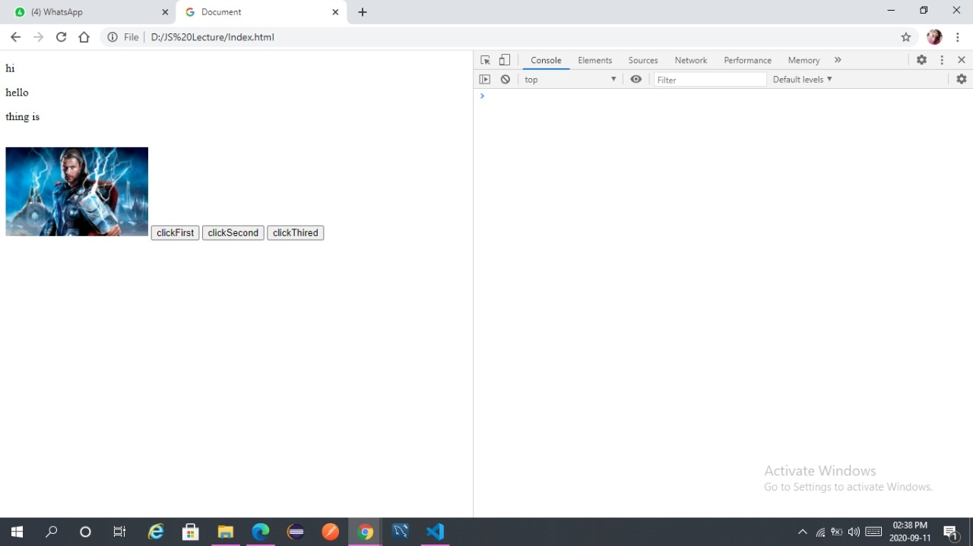

Question 3
let object={
name:"mayuri",
age:50,
country:"India",
hobbies:["cooking","travling","singing"]

}
console.log(object);

Output
